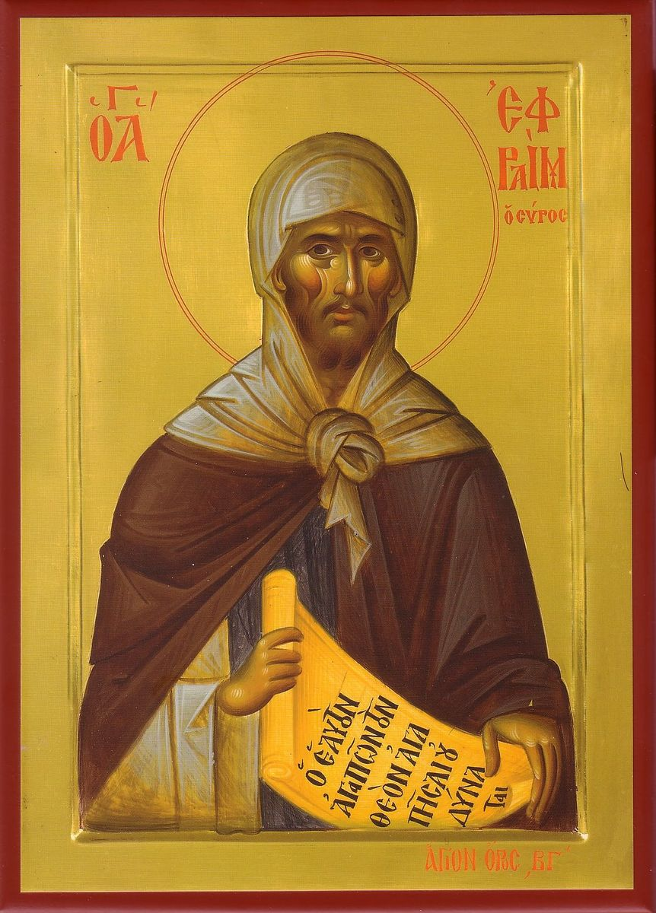

The Prayer of St. Ephraim 聖義範禱文

- O Lord and Master of my life, take from me the spirit of laziness, despair, lust of power, and idle talk. (All make a prostration.)  But give, rather, the spirit of chastity, humility, patience and love to Your servant. (All make a prostration.)  O Lord and King, grant me to see my own transgressions and not to judge my brother, for blessed are You unto ages of ages. Amen. (All make a prostration.) | 1.上主，我生命的主宰！求你從我身上除去懶惰、絕望、爭權及空談的心，（眾伏地）  但賜你的僕人貞潔、謙遜、忍耐和愛情之神。  （眾伏地）  我的主、我的君王，求你使我看見自己的錯誤，而不是判斷我的弟兄。你當受讚美，及世之世。亞孟！（眾伏地）
- God, be merciful to me a sinner. God, cleanse me of my sins and have mercy on me. I have sinned without number, forgive me, O Lord. (small reverence)  - God, be merciful to me a sinner. God, cleanse me of my sins and have mercy on me. I have sinned without number, forgive me, O Lord. (small reverence)  4 . God, be merciful to me a sinner. God, cleanse me of my sins and have mercy on me. I have sinned without number, forgive me, O Lord. (small reverence) | 2.天主，求你垂憐我罪人。  天主，求你洗淨我的罪，並垂憐我。主！我犯了無數的罪，求你寬恕我。（劃十字、鞠躬）  3.天主，求你垂憐我罪人。  天主，求你洗淨我的罪，並垂憐我。主！我犯了無數的罪，求你寬恕我。（劃十字、鞠躬）  - 天主，求你垂憐我罪人。  天主，求你洗淨我的罪，並垂憐我。主！我犯了無數的罪，求你寬恕我。（劃十字、鞠躬）
- O Lord and Master of my life, take from me the spirit of laziness, despair, lust of power, and idle talk.  But give, rather, the spirit of chastity, humility, patience and love to Your servant.  O Lord and King, grant me to see my own transgressions and not to judge my brother, for blessed are You unto ages of ages. Amen. (Prostrations at end) | - 上主，我生命的主宰！求你從我身上除去懶惰、絕望、爭權及空談的心，  但賜你的僕人貞潔、謙遜、忍耐和愛情之神。  我的主、我的君王，求你使我看見自己的錯誤，而不是判斷我的弟兄。你當受讚美，及世之世。亞孟！（眾伏地）

